SIMATS ENGINEERING (SAVEETHA SCHOOL OF ENGINEERING)
Department of Computer Science and Engineering
ASSESSMENT TOOL 1 – High (Coding Challenge)
Course Code: | CSA0901 | Course Title: | Programming in Java
CO Assessed: | CO1 – Precision (BL3,BL4) | Assessment: | Assessment Tool 1 – Coding Challenge
Weightage: |  | Total Marks: | 100 (5 Questions × 20 Marks)
CO1 Statement: | Apply object-oriented programming principles such as classes, objects, encapsulation, data hiding, inheritance, and polymorphism to design and implement entity manipulations (BL3,BL4)
Student Name: | Gokul.k | Reg. No.: | 1911260026
Section / Batch: | 2026 | Date: | 22-07-2026

Code of Conduct
I Gokul.k/1911260026 (Name / Reg No) certify that this submission is my original work and that I have adhered to the guidelines specified for this assessment. I understand that any violation of academic integrity rules will result in disciplinary action.

Signature of the Student: Gokul k

Instructions
- This test contains 10 questions, each carrying 10 marks. Total: 100 Marks.
- No negative marking. Unanswered questions carry zero marks.
- No calculators or electronic devices permitted.
- Duration: 90 minutes.

ANNEXURE
Coding Challenge

1. Library Book Management using Classes & Encapsulation
Design a Book class with private fields such as bookId, title, author, and price. Implement constructors, getters, setters, and methods to issue and return books. Create a menu-driven program to manage multiple books using an array of objects. Also, construct suitable test cases to validate book addition, issue, return, and search operations. BTL: BL3 (Apply)
Solution:
Program
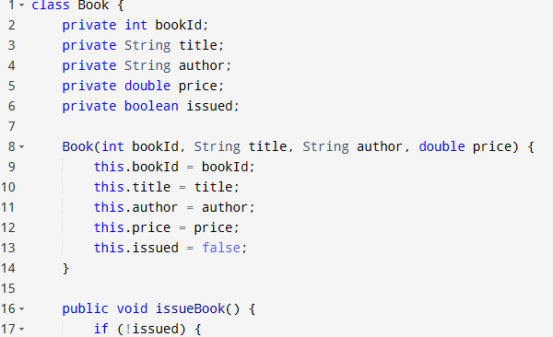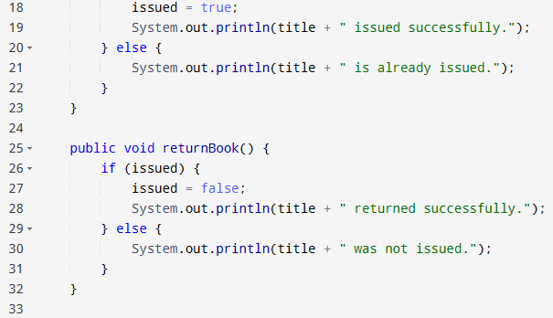
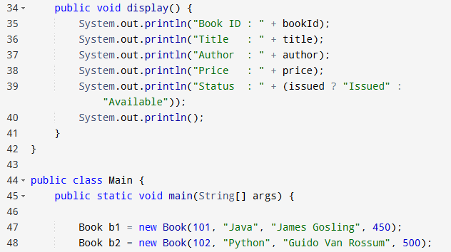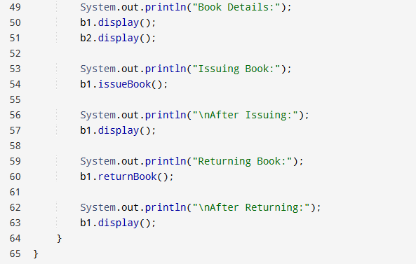

Output:
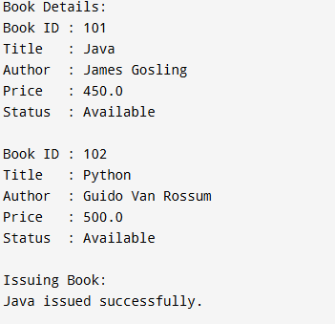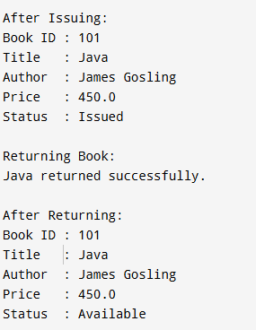

2. Employee Payroll System using Inheritance
Design a payroll system with a base class Employee and derived classes PermanentEmployee and ContractEmployee. Override a method calculateSalary() in each subclass to compute salary differently. Display employee details and salary using runtime polymorphism. Also, construct suitable test cases to validate salary calculation for different employee types. BTL: BL3 (Apply)
Solution:
Program:
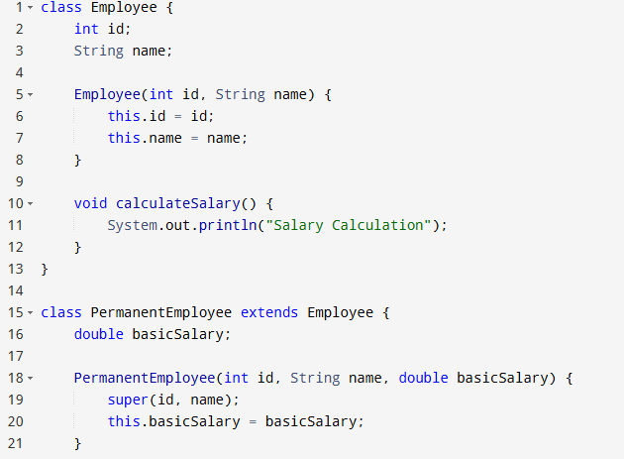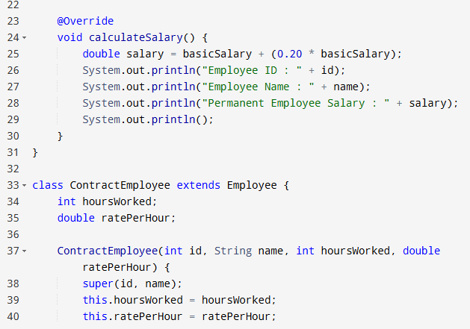
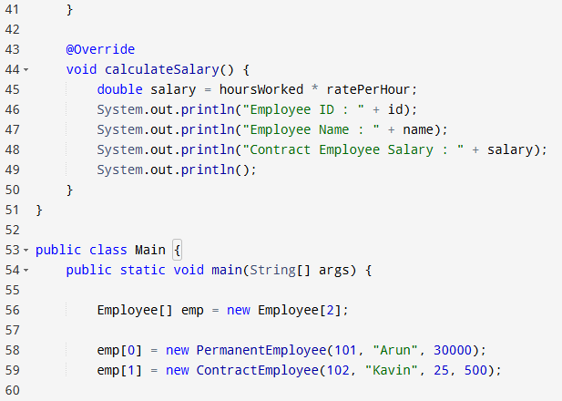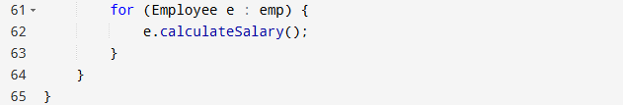
Output:
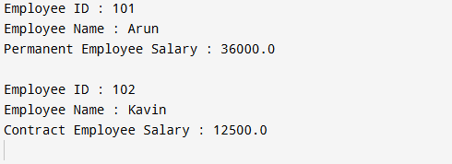

3. Vehicle Rental System using Runtime Polymorphism
Develop a vehicle rental system with a superclass Vehicle and subclasses Car, Bike, and Bus. Override the method calculateRent(int days) in each subclass. Store vehicles in an array of Vehicle references and generate rental bills dynamically. Also, construct suitable test cases to validate rent calculation for different vehicle categories. BTL: BL4 (Analyze)
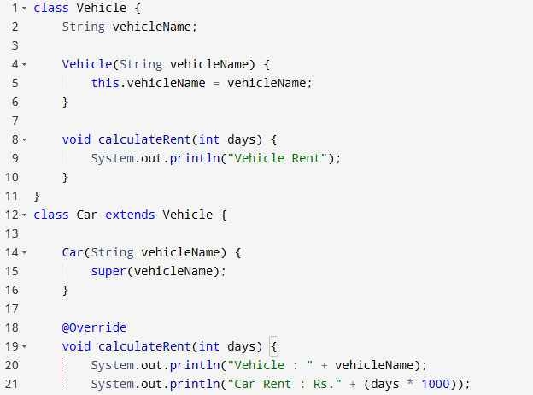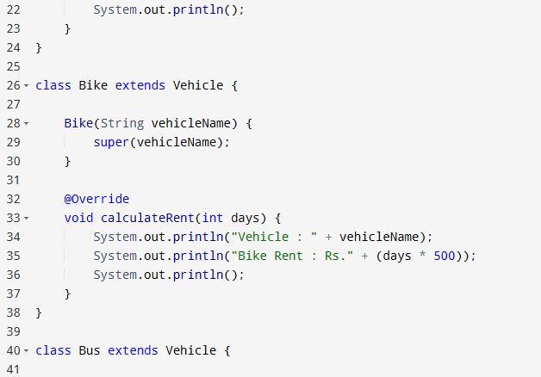
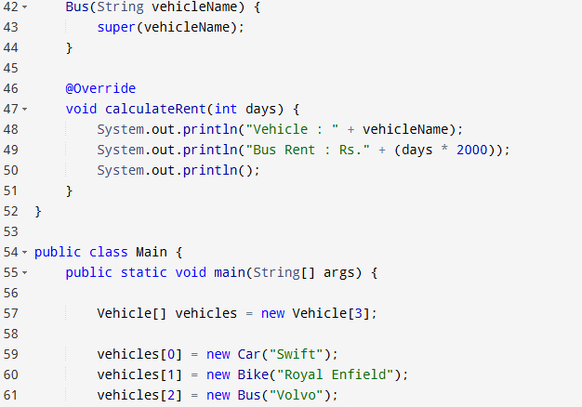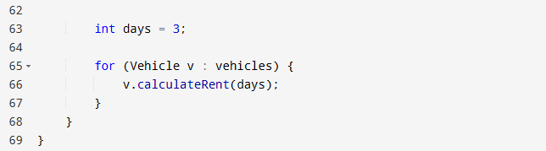
Output:
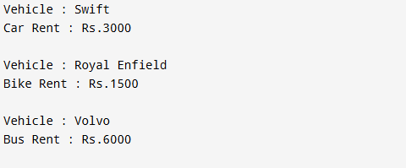

4. Bank Account System using Data Hiding
Design a BankAccount class with private fields accountNumber, holderName, and balance. Implement methods for deposit, withdrawal, and balance inquiry with proper validation. Prevent direct modification of balance from outside the class. Also, construct suitable test cases to validate valid and invalid transactions. BTL: BL3 (Apply)
Solution:
Program:
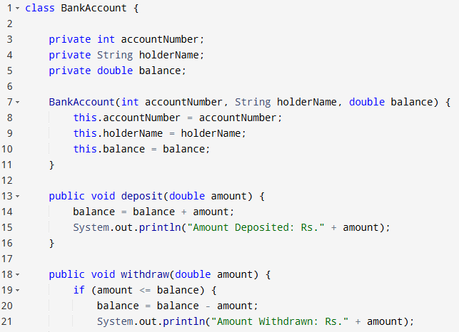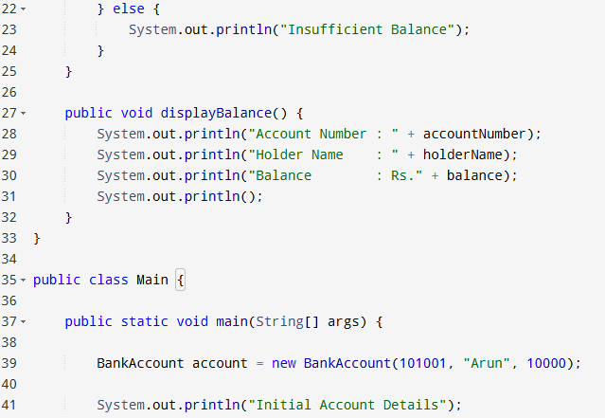
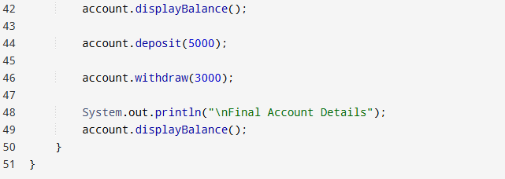
Output:
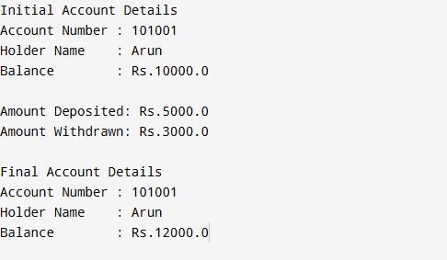

5. University Admission System using Method Overloading
Create an Admission class that overloads the method calculateFee() for:
- Undergraduate students,
- Postgraduate students,
- Scholarship students.
Display the fee structure based on user input and compare the overloaded method executions. Also, construct suitable test cases to validate each overloaded version. BTL: BL3 (Apply)
Solution:
Program:
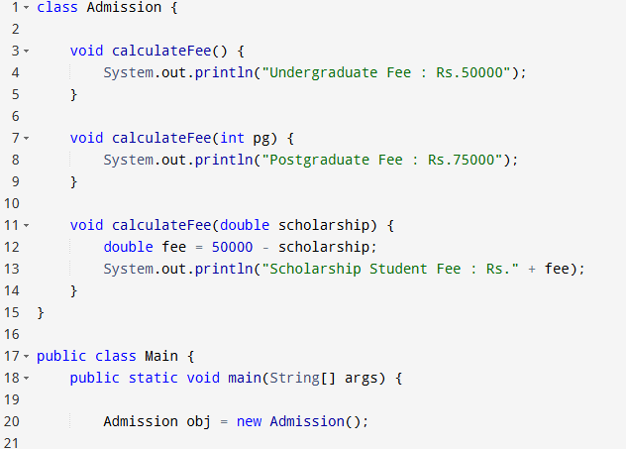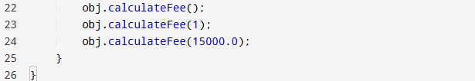

Output:

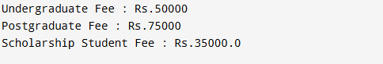

6. Shape Area Calculator using Abstract Class & Polymorphism
Design an abstract class Shape with an abstract method area(). Implement subclasses Circle, Rectangle, and Triangle. Use an array of Shape references to compute and display areas dynamically. Also, construct suitable test cases to validate area calculations and polymorphic behavior. BTL: BL4 (Analyze)
Solution:
Program:
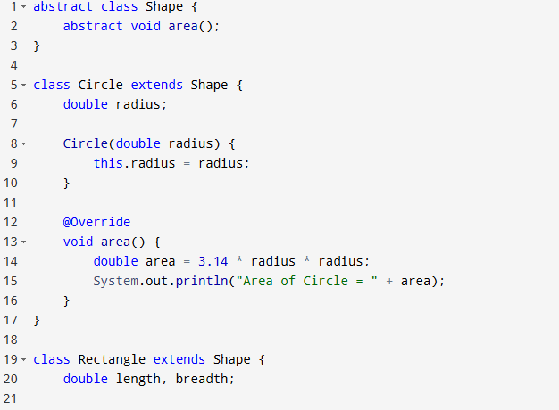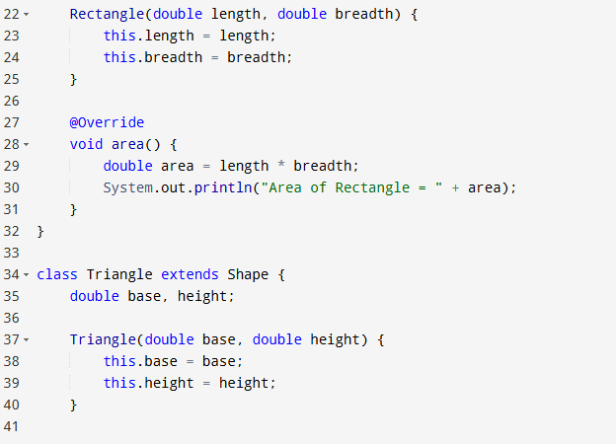
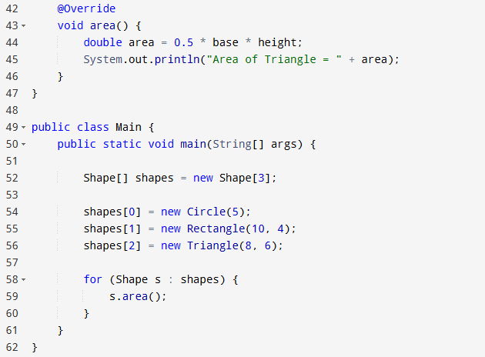
Output:
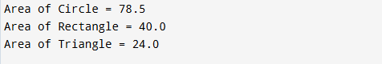

7. Hospital Management System using Interfaces
Develop a hospital management system with an interface MedicalRecord containing methods addRecord() and displayRecord(). Implement the interface in classes Patient and Doctor. Demonstrate interface-based abstraction and object interaction. Also, construct suitable test cases to validate record creation and display. BTL: BL3 (Apply)
Solution:
Program:
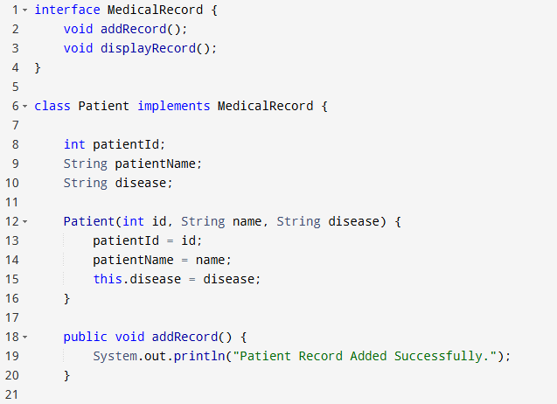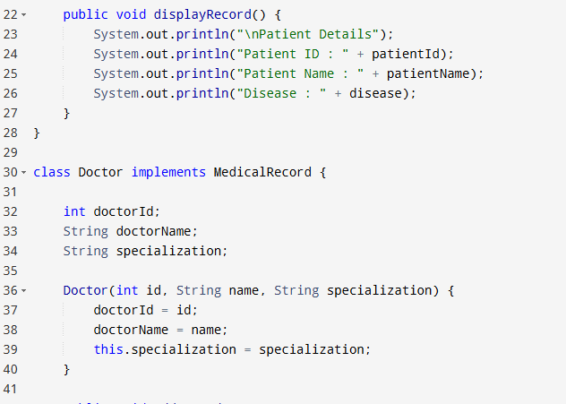
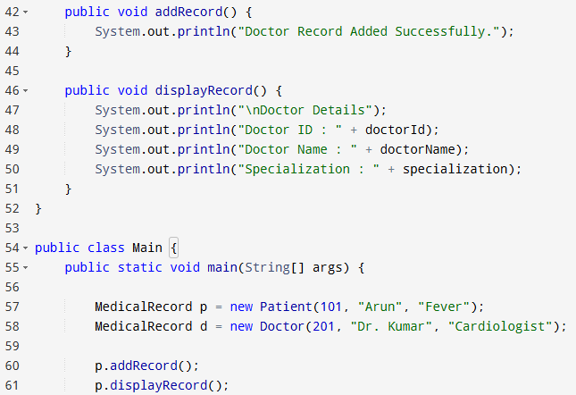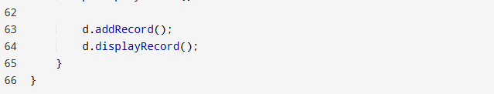
output:
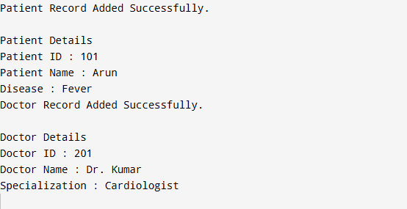

8. Online Shopping Order System using Packages
Create two packages:
- shopping.product
- shopping.order
Implement classes Product and Order in separate packages. Import the packages into a main application that places orders and calculates the total amount. Also, construct suitable test cases to validate package usage, order placement, and bill generation. BTL: BL3 (Apply)
Solution:
Program:
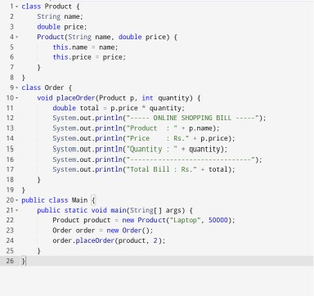
Output:
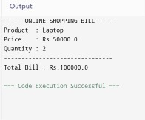

9. Student Result Analyzer using Arrays of Objects
Design a Student class containing roll number, name, and marks in three subjects. Store multiple student objects in an array and implement methods to calculate total, average, grade, and class topper. Also, construct suitable test cases to validate grading and topper identification. BTL: BL3 (Apply)
Program:
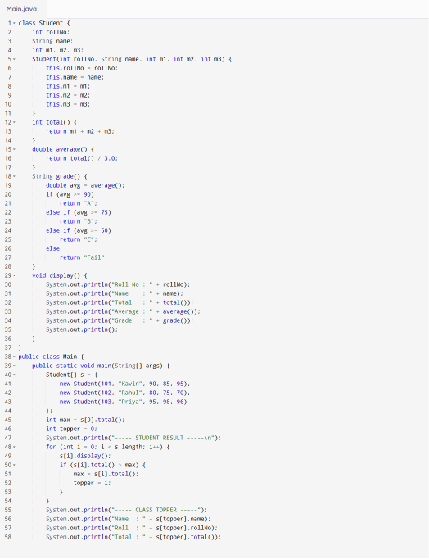
Output:
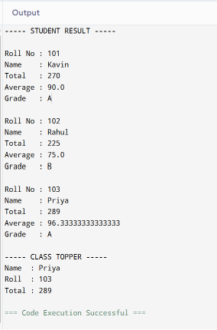

10. Smart Home Device Controller using Hierarchical Inheritance
Develop a smart home system with a base class Device and derived classes Light, Fan, and AirConditioner. Implement methods to turn devices on/off and display power consumption. Use polymorphism to control devices through a common reference. Also, construct suitable test cases to validate device operations and power calculations. BTL: BL4 (Analyze)
Program:
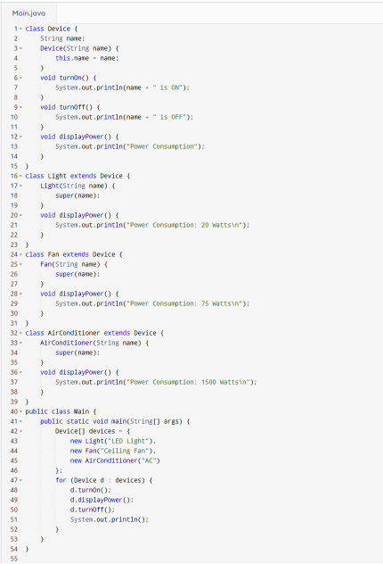
Output:
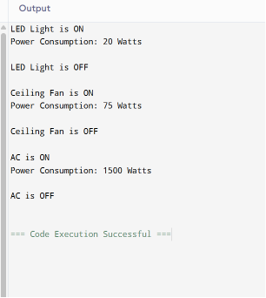

Rubrics for Calculation
Criteria | Weightage | Level 4 – Exemplary | Level 3 – Proficient | Level 2 – Developing | Level 1 – Beginning | Marks
Problem Understanding | 20% | Clearly understands problem  constraints, edge cases, and  competitive requirements | Understands problem with  minor gaps in  constraints | Partial understanding; misses key constraints | Misinterprets problem or constraints
Algorithm | 25% | Selects optimal algorithm with best  time and space  complexity for  competitive constraints | Uses efficient algorithm with  minor scope for improvement | Uses  basic/inefficient approach | No clear algorithmic approach
Code Implementation | 20% | Writes correct, efficient, and clean  code that passes all constraints | Code works with minor errors or  inefficiencies | Partially correct code; fails for some cases | Code does not execute or gives incorrect results
Competitive  Performance | 20% | Solves problem within time limits  and handles large inputs effectively | Solves within acceptable time with minor delays | Struggles with time limits or larger inputs | Unable to solve within time constraints
Test Case  Handling | 15% | Handles all test cases including  edge and hidden cases | Handles most test cases | Misses important edge cases | Fails on multiple test cases

Faculty In-charge | Course Coordinator | Head of Department
Signature: _______________ | Signature: _______________ | Signature: _______________
Date: ___________________ | Date: ___________________ | Date: ___________________

